# Beneficiary Analysis

# for the

# National College of Informatics Piatra Neamt

### Activity Profile

-Pre-university education including extracurricular activities that are not required for school credit that will be listed later on in this document.

### Organisational structure and employees

1. Teachers

|  |  |  |  |  |  |  |  |  |
| --- | --- | --- | --- | --- | --- | --- | --- | --- |
| Total no. | From which | | | | | | | |
| PhD. | Gr I | Gr II | Tutor | Entry Level | Qualified Substitute Teacher | Unqualified Substitute Teacher | Tenured Proffesor |
| 42 | 4 | 35 | 1 | 2 | 0 | 0 | 0 | 42 |

1. Auxiliary Teaching Staff

|  |  |
| --- | --- |
|  | No. |
| Secretary | 2 |
| Administrator | 1 |
| Librarian | 1 |
| Educator | 3 |
| Supervisor | 1 |
| System Engineer | 2 |
| Computer Scientist | 1 |
| Lab tech | 1 |
| Technician | 1 |
| Accountant | 2 |
| Total | 15 |

3.Non-teaching Staff

|  |  |
| --- | --- |
|  | No. |
| Janitors | 9 |
| Chefs | 4 |
| Workers | 3 |
| Driver | 1 |
| Security staff | 1 |
| Total | 18 |

1. Students-32 classrooms and a total number of 940 students

## Building Analysis

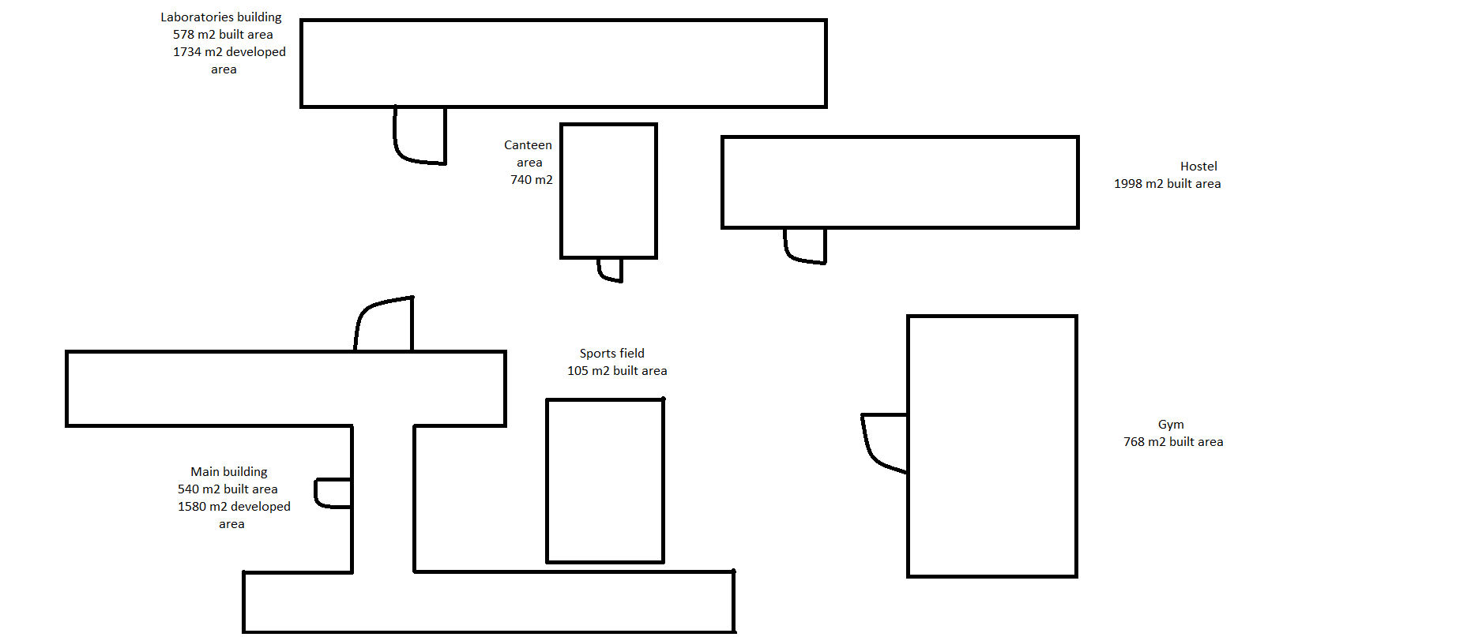

The Campus includes:

* 2 buildings for educational activities
* Gym
* Canteen Area
* Hostel
* Sports field and Inner Yard

**Main Building**

* Total built area 540m2  and developed area 1580 m2
* 3 levels
* 32 classrooms
* 7 offices
* Secretary office
* Accountant Office
* Library
* Teachers Office
* 3 Laboratory rooms
* 3 Laboratory annexes
* 2 teaching materials rooms
* 2 non-teaching materials rooms

**Laboratories Building**

* Total built area 578 m2 and developed area 1734 m2
* 3 levels+1 basement
* 3 maintenance rooms, 1 locker room , 2 bathrooms located in the basement
* 5 classrooms, 1 methodic room, 1 bathroom located on the first level
* 3 computer lab, 1 ROEDUNET centre, 3 offices, 1 bathroom on second level
* 1 Multimedia Lab, 2 computer Lab, 2 bathrooms on the third level

**Gym**

* Total built surface 768 m2
* Includes 1 equipment room, 1 teacher office, 1 materials room and 2 locker rooms

**Hostel**

* Total surface 768 m2
* 32 rooms
* 2 study rooms
* 5 bathrooms
* Showers
* 1 med room
* 1 students club room
* 1 educator office
* 1 administrator office
* 1 equipment room

**Canteen Area**

* Total built surface 740 m2
* 2 equipment rooms
* Store
* 2 Hallways
* 2 bathrooms
* 2 basements
* 1 cold room
* 4 storage rooms
* 1 office
* 1 locker room
* 1 washhouse

**Sports field**

* Total built area105 m2
* 1 handball field
* 1 track field
* Long jump runway

**Inner yard**

* Total surface 20660 m2

### Development plan

### Special conditions

-we need to be able to provide internet access to all buildings and security system